Cross Enterprise Cardiovascular Heart Team

Jump to: navigation, search

start content

**This is a template page.** [**CLICK HERE**](http://wiki.ihe.net/index.php/Category:Templates) **if you're not sure how to use it. DO NOT MODIFY this page unless you are changing the template for all future users.**

*This template is for the one or two page user-oriented overview of an IHE Profile that is in Final Text, Trial Implementation or perhaps Public Comment. Delete text in italics and replace it with your material. Don't forget to delete the double quotes too.*

*Your page name should simply be Full Profile Name with spaces, with capitals, without the acronym. e.g. Scheduled Workflow. so it provides a title to the page. You can redirect the acronym to the full named page if you like for bonus points.*

*<IN ONE LINE, tell a user what the profile is about (including the acronym) so they can decide if they're on the right page. Basically this should be the same sentence that appears on the* [*Profiles*](http://wiki.ihe.net/index.php/Profiles) *catalog page>*

*e.g. Scheduled Workflow (SWF) integrates ordering, scheduling, imaging acquisition, storage and viewing for Radiology exams.*

Cross Enterprise Cardiovascular Heart Team Workflow Definition Profile (XCHT-WD) orchestrates the creation of a dynamic network of cardiovascular professionals called Heart Team (HT), across multiple organizations and the exchange of data between their clinical health information systems.

**Contents** [hide]

* 1 Summary
* 2 Benefits
* 3 Details
* 4 Systems Affected
* 5 Specification
* 6 See Also

Summary

*<Describe the profile in about a paragraph using user-oriented language. Focus on what it accomplishes for a user (i.e. the Use Cases). Don't get into how it works, leave that to the Details section.>*

*<Insert a simple graphic that, at a glance, visually summarizes what the profile is about. Do not use an actor/transaction diagram here. Show your graphic to someone for 5 seconds (literally) and ask them what it's about. If what they say hits the main points in your summary paragraph, you have succeeded. E.g. a graphic of a hospital, a clinic, and a lab with patient records moving between them. .>*

*<See* [*Help - Tips and Tricks*](http://wiki.ihe.net/index.php/Help:Contents#Tips_.26_Tricks) *for details on inserting an image/graphic.>*

It is difficult to manage and coordinate remote interaction among healthcare professionals involved in a multidisciplinary and dynamic team on cardiac diseases (Heart Team) that they support community hospitals. The sharing of information is a critical component in establishing an efficient use of the HT. It is critical that different types of documents and information are easily accessible while the HT is making its evaluation. There are existing profiles that define the sharing of documents and the notification but is not enough to manage dynamic team.

The XCHT-WD Profile defines the workflow, intended as a common set of rules and activities, related to the collaboration of the members of a dynamic network of cardiovascular professionals that belong to different hospitals, called a Heart Team (HT), to facilitate appropriate decision making on the treatment or intervention used for patients and to better manage the knowledge exchange.

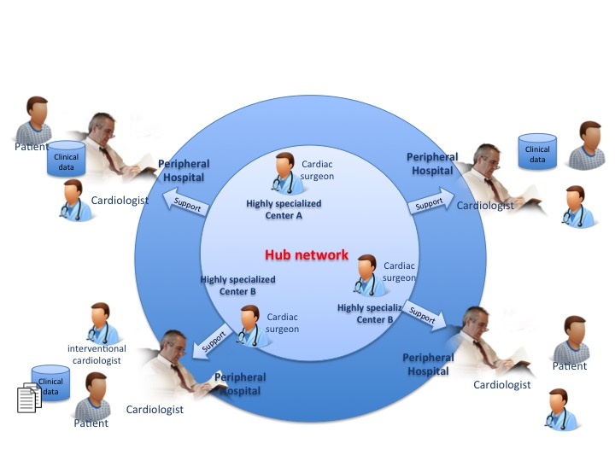

Benefits

*<If the profile can improve Cost, Safety, Quality or Efficiency then list the specific examples of that benefit (e.g. error reduction, increased throughput) and how they come about (e.g. SWF reduces patient errors due to mistyped demographics at the modality by transfering demographics electronically from the Order Filler). Consider using a bullet list for readability. Such benefits help users and vendors make the business case for the profile. If the profile does not improve any aspect of Cost, Safety, Quality or Efficiency feel free to talk about something else here.>*

The XCHT-WD Profile provides a common workflow that:

* facilitate the management of a dynamic and flexible team of professionals as Heart Team, involved in many cardiological clinical cases, that has to support the cardiologist in the taking decision
* improve the efficient sharing of information (right data to right professionals)
* accelerate taking decision

Details

*<A few paragraphs, if appropriate, providing more details (mostly in user-speak, not tech-speak) on what the profile does and how it works.>*

*<If the user might be familiar with the mechanisms used by the profile, you can mention them here. E.g. Evidence Documents is based on DICOM Structured Report (SR) Templates.>*

*<If the user might have an appreciation for the problems addressed in the profile, you can mention them here, but keep it short. E.g. Mapping HL7 Order fields to DICOM Modality Worklist attributes can be inconsistent in the marketplace, so Scheduled Workflow provides vendors with more detailed instructions.>*

The XCHT-WD Profile defines rules and tasks of members of Heart Team and data to be shared, in a common workflow applied to Heart Team. This profile is built upon the XDW Profile, it needs to be supported by

* XDS.b and XDS-I Profiles to allow for the sharing of clinical documents and workflow documents
* DSUB Profile to allow for the notification of availability

XCHT-WD Profile will be one alternative to help to fill the gap in workflow management, providing links for relevant/required clinical information to specific workflow tasks of the HT.

Systems Affected

*<List (in user terms) the types of systems they might expect to have implemented actors from this profile, e.g. RIS, PACS, HIS, CAD Workstation, etc. and for each, how it would participate.>*

* *PACS systems may store, manage, and/or display Evidence Documents.*
* *Display systems may query, retrieve and display Evidence Documents.*
* *Reporting workstations may retrieve, process and include details from Evidence Documents in reports*

Systems that can be involved in the process described above are:

● CIS system

● Hospital EHR system

● HIS

**Actors & Transactions:**

*<Insert an actor-transaction diagram, and or list of Content Definitions>*

The systems participating into XCHT-WD needs to create the XDW Workflow Document, consume and update its.

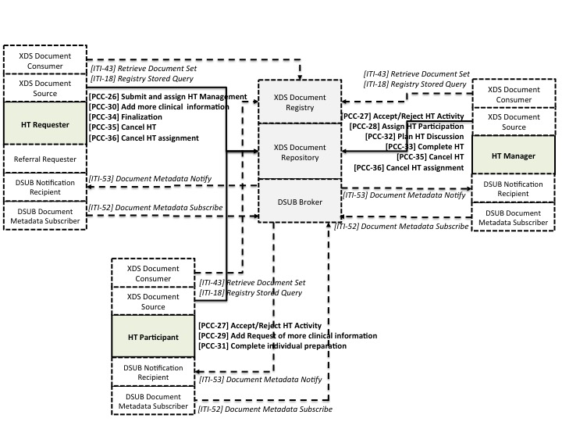

These transactions defined how the actors have to create and update the workflow document on bases of their rules and how the workflow document has to be shared and notified. These transactions is based on existing IHE document sharing profiles in particular XDS profile.

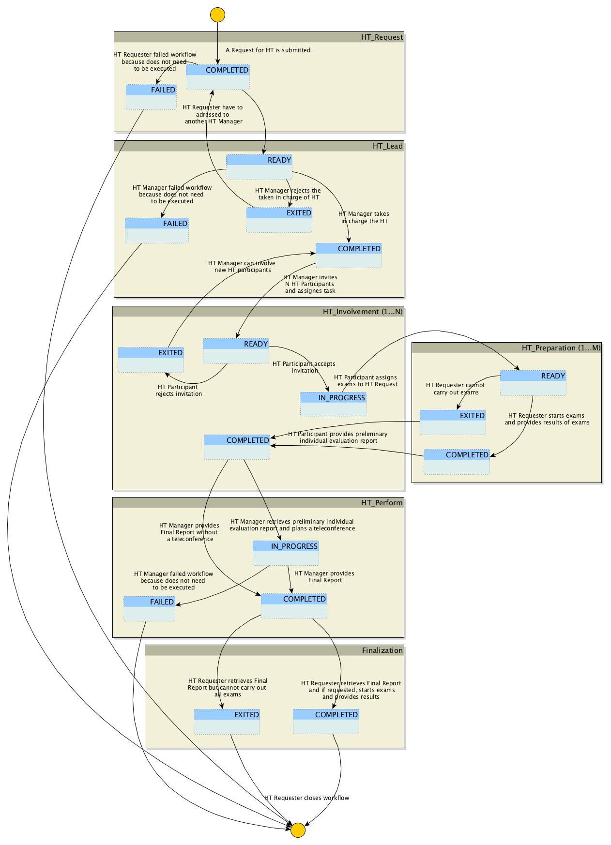

Specification

**Profile Status:** Trial implementation *<Replace "Final Text" with "Trial Implementation" or "Public Comment" as appropriate.>*

**Documents:**

*<Provide direct links to the specific volumes or supplements, and list the volume sections relevant to this profile. This is a simple inventory of official normative and informative text. If you would like to provide a reading guide or walkthrough of what is in each of the different sections for implementers or users, do that in the Profile FAQ or the Profile Implementation Page linked below. If the profile uses transactions from multiple Tech. Frameworks, repeat the structure below.>*

XCHT-WD Supplement

**Underlying Standards:**

*<list all the standards on which the profile is based; if possible with links to sources>*

* [OASIS](http://www.oasis.org/) Web Services – Human Task (WS-HumanTask) Specification Version 1.1
* [HL7](http://www.hl7.org/) CDA Release 2.0 and Reference Information Model.

See Also

*<The following sections can be left out if there is nothing to point to. This is just to show where such information can go.>*

**Related Profiles**

*<List profiles this one depends on, profiles that depend on this one, profiles that are synergistic with this one. Start with the name of the other profile as a link and then explain the relationship.>*

The XCHT-WD profile depends on other IHE profiles:

* [Cross-Enterprise Document Sharing](http://wiki.ihe.net/index.php/Cross-Enterprise_Document_Sharing) [XDS] may be used to share the XDW Workflow Documents and the input and output documents referenced by each workflow instance.
* [Cross Enterprise Workflow](http://wiki.ihe.net/index.php/Cross_Enterprise_Workflow) coordinates human and applications mediated workflows across multiple organizations.
* [Document Metadata Subscription](http://wiki.ihe.net/index.php/Document_Metadata_Subscription) describes the use of subscription and notification mechanism for use within an XDS Affinity Domain and across communities.

**Consumer Information**

The [Profile FAQ Template](http://wiki.ihe.net/index.php/Profile_FAQ_Template) answers typical questions about what the Profile does. *<Replace the link with a link to the actual FAQ page for the Profile>*

The [Profile Purchasing Template](http://wiki.ihe.net/index.php/Profile_Purchasing_Template) describes considerations when purchasing equipment to deploy this Profile. *<Replace the link with a link to the actual Purchasing page for the Profile>*

**Implementer Information**

The [Profile Implementation Template](http://wiki.ihe.net/index.php/Profile_Implementation_Template) provides additional information about implementing this Profile in software. *<Replace the link with a link to the actual Implementation page for the Profile>*

**Reference Articles**

*<List References (good and bad) (with link if possible) to Journal Articles that mention IHE's work (and hopefully include some analysis). Go ahead, Google: IHE <Profile Name> abstract or Google: IHE <Profile Name> and under the "more" select "Scholar". You might be surprised. >*

This page is based on the [Profile Overview Template](http://wiki.ihe.net/index.php/Profile_Overview_Template)

*<****Delete this Category Templates line*** *since your Profile page is no longer a template.>*

PCC Vocabulary Registry and Data Dictionary

Transactions:

[PCC-26] Submit and assign HT Management

[PCC-27] Accept/Reject HT Activity

[PCC-28] Assign HT Participation

[PCC-29] Add Request of more clinical information

[PCC-30] Add more clinical information

[PCC-31] Complete individual preparation

[PCC-32] Plan HT Discussion

[PCC-33] Complete HT

[PCC-34] Finalization

[PCC-35] Cancel HT

[PCC-36] Cancel HT assignment